To complete this lab you need a photo of your woven square, if you do not have one ask your teacher to provide you with theirs. Read the instructions below thoroughly and complete all tasks.

Save your image of your weaving to the desktop.
Go to www.desmos.com .
Use the plus (+) sign on the top left of the page to add your image onto the coordinate plane.
Center your image anywhere you wish.

Choose one of the colours in your square to use for this lab. You will use the same colour to answer all questions. The colour you have chosen is _________________.

Your task is to write linear equations which will follow the lines created by your chosen colour of wool/cedar on your square. The general equation of a straight line is given by:
$$y=mx+b$$
Where $m$ is the slope and $b$ is the $y$ – intercept.
Type your equations into desmos to check that you are correct, each equation should produce a line which follows the path of your chosen colour through your woven square. Do this for 3 separate lines.

What do you notice about the slopes of all of these lines? ______________________________________

Your next task is to restrict the domain or range of each line so that its end points correlate with your image. A domain or range must be contained within a curly bracket in Desmos, for example:
$$y=2x-1 \{-2≤x≤5\}$$
Will draw a line with a slope of $2$, a $y$ – intercept of $-1$ and it will begin at $x=-2$ and end at $x=5.$
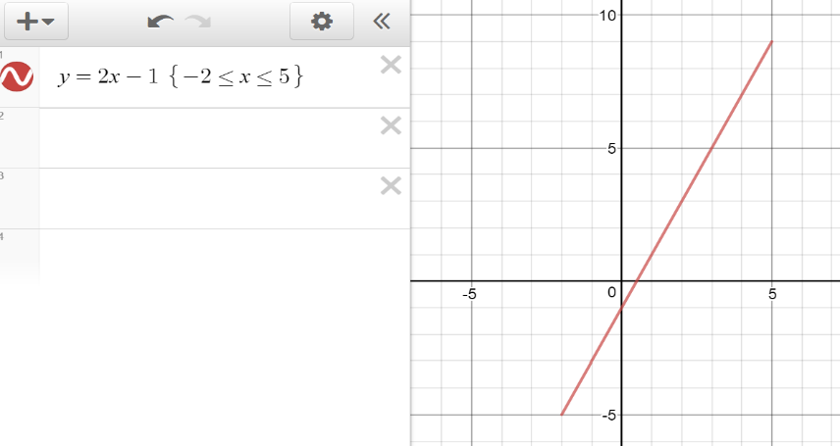

Take a screenshot of your work and paste it into a Word document. You may use the Snipping Tool to help you do this. Make sure your equations are visible as well as your image. Save your work.

Open your photo directly from where you saved it on the desktop. Rotate your image $90°$ clockwise or anticlockwise and save it.
Open a new tab in your web browser and again go to www.desmos.com .
Add your rotated image into desmos as you did earlier using the plus (+) symbol. Center the image at the same location you chose previously.

Repeat your earlier task for the same strands of wool/cedar as earlier. Write the equations of the lines, enter them into desmos to check your work and restrict the domains or ranges.
Take a screenshot of your work and paste it into your Word document below your last one.

What do you notice about the slopes of these new lines? _____________________________________

Take a few minutes to review your work then answer the questions below.

What do you notice about the slopes of parallel lines?
_____________________________________________________________________________________
What do you notice about the slopes of perpendicular lines?
_____________________________________________________________________________________

Write your name at the top of your Word document and save it. Ask your teacher if they would like you to print your work or send it to them via email. Hand in this completed worksheet.
Great work!

Please return to your workbook and continue from wherever you left off last time.
OR
Design a pattern you would like to see on a woven square using desmos. Make sure to restrict the domains or ranges so as to keep the pattern within a square. You do not have to limit yourself to straight lines. Print your pattern and take it home. Bring back your pattern accompanied with a completed woven square with your design on it for extra credit. Happy weaving!!

