Britannia Secondary Course Outline 2019-20
The mission of Britannia Secondary Community School is to graduate responsible citizens with the knowledge, skills and attitudes necessary to fulfill their potential for lifelong success.
Course: Venture Math 10 Teacher: Ms Mackie Email: dmackie@vsb.bc.ca
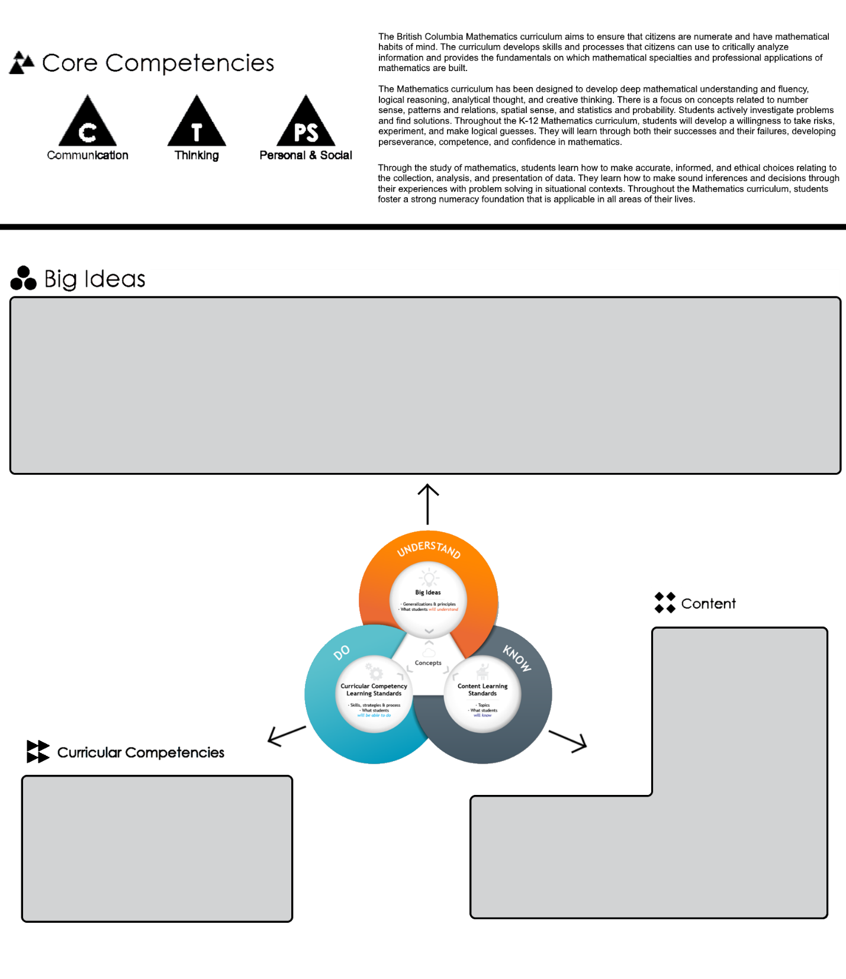
Venture Math 10 is an exciting and challenging course that opens the door to many beautiful areas of mathematics not explored in previous years. We will complete the Foundations and Pre-Calculus Math 10 curriculum and supplement throughout with pre-IB topics.

- Algebra allows us to generalize relationships through abstract thinking. | - The meanings of, and connections between, each operation extend to powers and polynomials. | - Constant rate of change is an essential attribute of linear relations and has meaning in different representations and contexts. | - Trigonometry involves using proportional reasoning to solve indirect measurement problems. | - Representing and analyzing situations allows us to notice and wonder about relationships.

- powers
- prime factorization
- functions and relations
- linear functions
- arithmetic sequences
- polynomial factoring
- trigonometry
- financial literacy

- Reasoning and modelling
- Understanding and solving
- Communicating and representing
- Connecting and reflecting

- systems of equations
- polynomial expressions

For specific learning outcomes please refer to the following website:
https://curriculum.gov.bc.ca/sites/curriculum.gov.bc.ca/files/pdf/10-12/mathematics/en_m_10_fpc_elab.pdf
Assessment/Evaluation:

Grading will be done on a term by term basis, each term being weighted equally and broken down as follows:

35% Partner quizzes
25% Projects
40% Cumulative Test

One class each term will be set aside as a “catch-up” class. You may use this time to get help on previous topics or preview upcoming topics.

Tutorial:
Tutorial time is YOUR time, use it as you wish but please do use it, it really does make a difference. I will be available in my room from 8:30 am to 9 am every day to help you with any math questions you may have, you may also just use the classroom as a space to work independently or with peers.

Attendance:

It is expected that you will attend all classes prepared and on time. If you are unavoidably absent from a class it is expected you take full responsibility for making up all missed work.

Supplies:

Workbook (last years), binder with lined paper, pencils, eraser and ruler.
Coloured pens – optional but useful to organize notes, shade areas or help with art projects.
Scientific calculator - it is recommended you always use the same model of calculator in order to help with confidence and accuracy.

Class Expectations & Code of Conduct:

RESPECT – Yourself, those around you and your environment.

Our school code of conduct may be found by following this link:
http://britannia.vsb.bc.ca/about_britannia/Britannia%20Code%20of%20Conduct%20and%20Ministry%20Requirements.pdf
Please note that this course outline may be adjusted throughout the year to tailor to the specific needs of your class as the course progresses.
I look forward to sharing a fun and successful year with you
www.mathwithmissmackie.weebly.com

