Venture 8 Math - Integer Operations Partner Quiz

**No Calculators 😊**

1. Add.

a) -16 + (-4) b) 2 + (-13) c) -15 + 8 d) -17 + (-4) e) -13 + -13

a) ________ b) ________ c) ________ d) ________ e) ________

2. Subtract.

a) 13 - (-6) b) -12 - 7 c) -9 - (-5) d) 24 - 39 e) 7 - 17

a) _______ b) ________ c) ________ d) ________ e) _________

3. Multiply. *Note that $1×2=1∙2=1\left(2\right)=\left(1\right)2=(1)(2)$.*

a) -4 $∙$ 5 b) -5(-2) c) 7 x (-3) d) -12 x (-10) e) 5(-5)

a) _______ b) _______ c) _______ d) ________ e) _________

4. Divide.

a) -14 ÷ 2 b)  c) 21 ÷ (-7) d)  e) -6 ÷ (-6)

a) ______ b) ______ c) ______ d) ______ e) ______

5. Put it all together. BEDMAS. *Show all your work neatly and use = appropriately.*

a. $4(3 – 10) + 2 – 11$ b. $-2[4 + (-3)-5]$

c. d.

e. f.

g. h.

6. a. What multiplication statement is b. Draw a tile diagram which models $2-\left(-1\right).$

being modelled below?

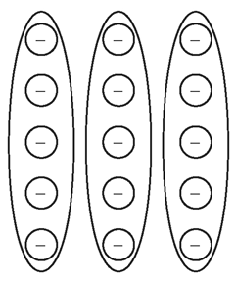

7. Describe a scenario which could be represented by $2(-3)+(-1)$.

Extras. Be careful with some of these! Recall that a power is shorthand for repeated

multiplication.

a) (-6)2 b) -24 c) (-5)2 d) (-1)72 e) 

a) ______ b) ______ c) _______ d) _______ e) _______