- When does one use the different rules, like product, quotient and chain rules?
When one has a product, chain or quotient to differentiate.
Product $f\left(x\right)×g(x)$
Chain $f\left(g\left(x\right)\right)$
Quotient $\frac{f\left(x\right)}{g\left(x\right)}$

- How can one identify which rule or method is best to solve a question?
This will become easier with more practice.
Also see above.
Come to tutorial with a specific question and perhaps I can offer more suggestions.

- What is the proof for the quotient line?
I have no idea what this means.
- How does one find the tangent and normal lines?
Find the slope of the curve at the point of tangency using differentiation. This is the slope of the tangent line and the negative reciprocal of the slope of the normal line. Substitute this and the coordinates of the point into the equation $y=mx+b$ and solve for $b$ or use point-slope form $y-y_{1}=m(x-x_{1})$.
- Why is the normal line the negative reciprocal of the tangent line?
Because they are perpendicular to each other.
- How does one do the questions that give you one point on a tangent and ask for the equation of the line (or something like that)?
See question 4.
- How does one do optimization?
Often by modelling the situation to be optimized with a function and using Calculus to find the stationary points (maxima or minima occurring at the optimal input values).
Example – Parabola models profit of a business based on production, increasing production increases profitability initially but eventually you produce too much and profit goes down, the maximum of this parabola is the optimal production to maximise profit.
- How much calculus is going to be on the paper?
The following table states the hours IB expects we allocate to each topic, the weighting should give you some idea.
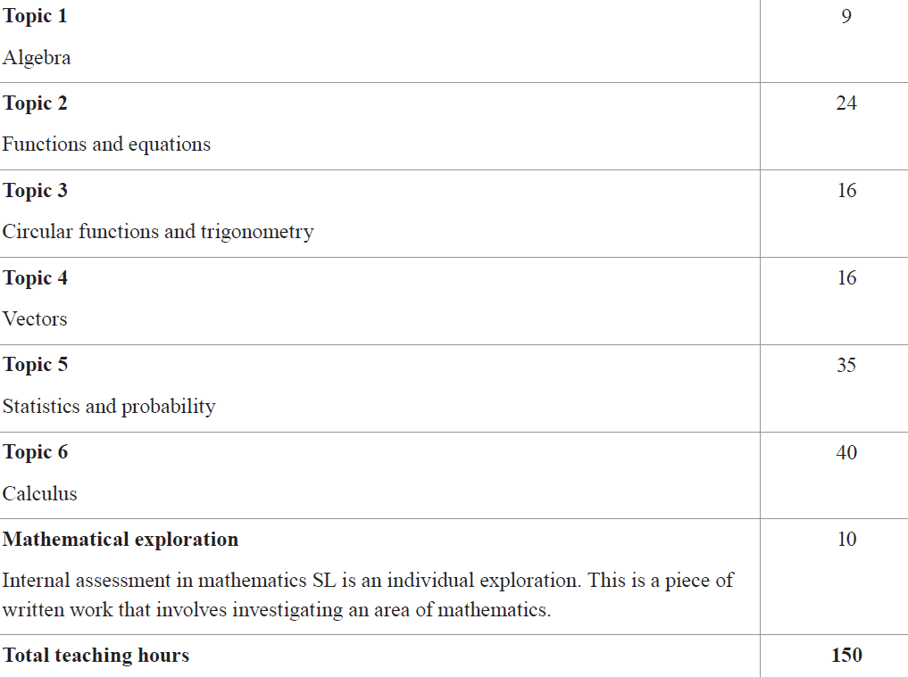
- What are some real-life applications of calculus?
Differential calculus is the study of rate of change which has applications in terms of motion, acoustics and astronomy. Calculus can describe the behavior of functions, curves, surfaces, solids and many other mathematical objects. It helps model situations and provide information helpful to graphing these situations which can lead to predictions and help with optimizations. Google it
- What is the purpose of learning calculus when it is only used in very specific situations?
I don’t believe it to be true that Calculus can only be used in very specific situations, it has quite broad applications.
- What level of difficulty is the calculus we learn in IB? Is it Calc 1? Is this what we learn in 1st year university?
How is this helping you prepare for your IB exam? Search the curriculum of the university course you are interested in and compare with what you know. You don’t study Calculus to any great depth in IB SL.
- How can learning about vectors help us with real life situations?
You can predict how objects will move under certain forces. For example, wind pushes a plane off course, understanding vectors helps with knowing what correction the pilot must make to account for the wind and stay on course. Crossing a river in a canoe, if you wish to reach a certain point but the current is pushing you downstream you have to angle your canoe upstream to account for this force and still land at your chosen point. It’s all vectors
- What are some of the most common questions given marks? What needs to be shown?
See question 8. Also review your “Command Terms” hand out, this helps identify how much work needs to be shown. If work is required what work will depend on your method, enough should always be given such that your solution is logical to the reader and can be followed with ease. For calculator questions an explanation of what you are calculating should be given, this may be in the form of a sentence or the math, an integral for instance.
HL
- In doing integration by parts, why do you take the derivative of u and input $\frac{1}{\frac{du}{dx}}$ as a coefficient of the integral? I’m not sure I understand this question but I have uploaded a file called “Why integration by parts works”, see if this answers your question, if not come and see me.

- How does one calculate the volume of a solid of revolution that does not touch the x-axis (like a torus)? Split the cross section of the torus (circle) into two semi-circles, use these independently to calculate two volumes and subtract.

- How does one do trig substitution (and Weierstrass substitution)? See “Weierstrass substitution” file I have uploaded.

