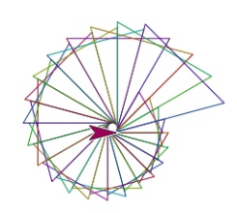
Today you are going to apply your geometry skills to make computer programs (called scripts) to draw various polygons and spirographs.
The coding platform: We will use Snap!, a block-based programming language.
Go to snap.berkley.edu and click Run Snap! Now.
Some Snap! Tips:
- On the left is the Palette area (with colour-coded commands). The scripting area is in the middle (drag the blocks here to make your code), and the stage is at the right (see what your code does here).
- Whenever you want to delete a block, just drag it back to the palette.
- Any object you move around is called a sprite (or turtle).
- You will not be creating an account today so you cannot save your work.
Try the following activities. If you need help ask your partner first, if your partner cannot help then raise your hand.

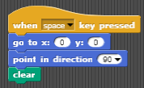
Activity 0: Clear the screen
Think: What do you expect this code will do?
Drag command blocks from the palette into the scripting area to create this code.

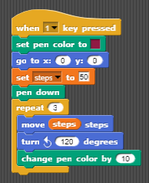
Activity 1: Triangle
Here is the code to draw an equilateral triangle.
Look at each line, one by one.
Think: What does each command do?
Think: Why is it 120 degrees?
Copy the code to draw your own triangle.

Activity 2: Square
Duplicate your triangle code (right click on the code, let go, then drag the duplicated code over a bit; you can then start modifying it).
Change your code so that it draws a square when the “2” key is pressed. What changes do you need to make? Hints:
- Number of sides in a square: ____
- Sum of exterior angles of a square: ________ degrees
- Exterior angle of a square: _________ degrees

Challenge 1: Similar Polygons
Create a code which will draw 2 similar (not congruent), regular polygons. Your polygons must have at least 5 vertices and must not overlap or be connected by any extra lines.
Once you have completed this challenge show Ms Mackie and get her to initial here: _______

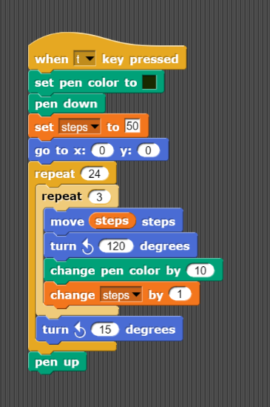
Activity 3: Spiral Triangles

Duplicate the triangle code from activity 1. Modify it to match this code. What does this code do?

What does this line with the “24” do?

What’s this “Change steps by 1” command do? (Try your code with and without it to see the difference!)
What’s this “turn 15 degrees for?”

Activity 4: More Spiral Polygons
- Modify the code from activity 2 to make a spirograph.
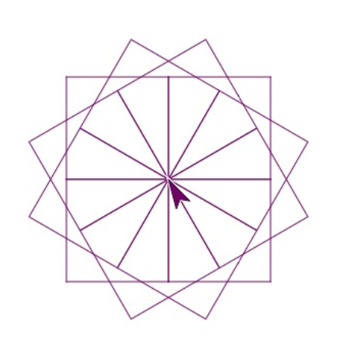
- Can you create any of the spirographs below, exactly?!? Go for it!
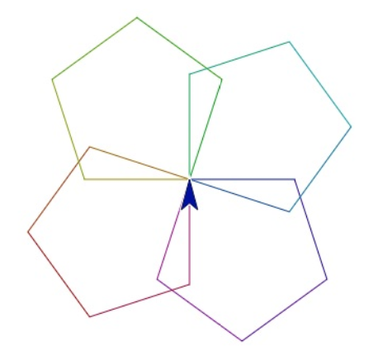

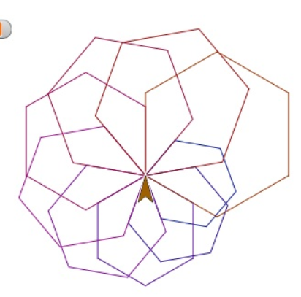
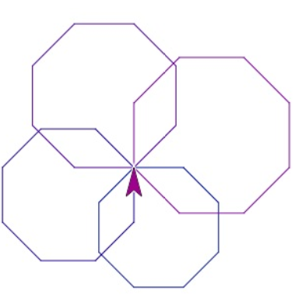

Exploration:
Check out Spirograph Designer! Play around with it to design your own pattern. You can see the code by clicking “see inside” at the top right corner: https://scratch.mit.edu/projects/202510579/

Activity 5: Explore! (10 minutes)
- Investigate commands in the palate area that you have not yet used.
- Change your sprite so it no longer looks like an arrow. Hint: Look below the stage, on the right.

Challenge 2
Get two different sprites to draw 2 congruent polygons simultaneously (at the same time).
Once you have completed this challenge show Ms Mackie and get her to initial here: _______

Congratulations!! You have successfully completed our first coding lab

