PC 11 ***FINAL EXAM REVIEW***

1. Given the arithmetic sequence -23, 7, 37, ..., determine: a.  b. 
2. How many terms are in each arithmetic sequence? a. 53, 45, 37,...., -75 b. -2.5x, 3, 2.5x + 6, ..., 17.5x + 24
3. Insert four numbers between 61 and 92 so the six numbers form an arithmetic sequence.
4. Write the formula for the general term of a sequence. a. 8, 12, 16, … b. 9.8, 8.2, 6.6, …
5. A sum of $78 was deposited in a bank in January. A sum of $24 is deposited at the beginning of each month after that. How much money will be in the bank on December 31st of that year?
6. Determine the sum of the first 14 terms of each arithmetic series: a. 4 + 11 + 18 + … b. 12, 3, -6 ...
7. Determine the sum of each arithmetic series: a. 4.2 + 5.8 + 7.4 + ... + 34.6 b. 4 + 1 - 2 -...- 50
8. If a = 8, tn = 121, and Sn = 838.5, determine the number of terms in the arithmetic series..
9. For three summer months (12 weeks), Job A pays $325 per month with a monthly raise of $100. Job B pays $50 per week with a weekly raise of $10. Which is the better paying job?
10. Determine the indicated term of each geometric sequence. a. 4, -16, 64, …, **t7**b. 20, 16, 12.8, …, **tn**
11. In a geometric sequence, the 3rd term is 7 and the 5th term is 175. Determine the value of the second term.
12. A bacteria population doubles in number every 3 hours. If there are 40 individuals right now, how many will there be in 24 hours time?
13. A runner starts by jogging 4 kilometres. He increases his distance by 10% each time he runs.
    1. The distance he runs on the 8th day b. The total distance he has run after 8 days.
14. For each geometric series, determine the indicated sum. a. 240 -120 + 60... **S8** b. 7 + 21+ 63 ...**Sn**
15. Determine the infinite sum of each geometric series. a. 64 - 48 + 36 ... b. 140 + 70 + 35 + ...
16. If = 90 and r = -0.3, determine the value of a.
17. The length of the initial swing of a pendulum is 40cm. Each successive swing is 0.74 times the length of the previous swing a. What is the total distance the end of the pendulum travels after 6 swings?

b. What is the total distance the end of the pendulum travels before it comes to rest?

1. For each angle in standard position, determine the reference angle.
   1. 48˚ b. 242˚ c. 198˚ d. 337˚ after being reflected in the x-and y- axis
2. Determine the exact values of each of the following angles.
   1. cos 0˚ b. sin 45˚ c. tan 90˚ d. cos 30˚ e. sin 90˚ f. tan 60˚
3. Determine the exact values of each of the following angles.
   1. cos 210˚ b. sin 315˚ c. tan 135˚ d. cos 150˚ e. sin 135˚ f. tan 300˚
4. Point P (-7, -24) lies on the terminal arm of angle θ, in standard position. Determine the exact values of sin θ, cos θ, and tan θ
5. If the terminal arm of θ is in quadrant 2, and cos θ = , determine the exact values of sin θ and tan θ.
6. Determine θ, if 0˚≤ θ < 360˚. a. tan θ = b. sin θ =  c. cos θ = 
7. Solve the following triangles.

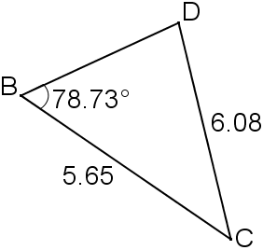

* 1. b. c. a = 36 cm,

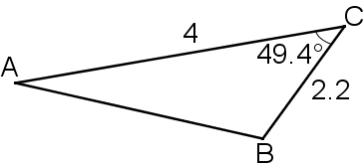

c = 42 cm,

∠A = 38˚

1. How does the graph of a quadratic function in the form  change when
   1. The value of *p* is decreased by 5 and the value of *q* increased by 4.
   2. The value of *a* is multiplied by a factor 0.5 and the value of *q* is decreased by 9.
2. State which graph corresponds to each function.

a)  b)  c)  d) 

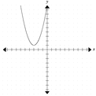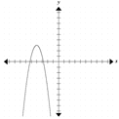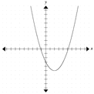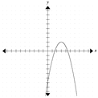

1. Graph. State the vertex, equation of axis of symmetry, x-and y- intercepts, domain and range, and the maximum or minimum value
2. Determine the equation of the parabola that has a vertex of (-3, -5) and passes through (1, 20).
3. Convert  to standard form ().
4. If the point (-3, 30) is on the graph , where will the point be on ?
5. Complete the square. a.  b. 
6. Solve a. The sum of two numbers is 46. Their product is a maximum. Find the numbers.

b. Two numbers have a difference of 6. The sum of their squares is a minimum. Find the numbers.

c. A rental business charges $12 per canoe and averages 36 rentals a day. For every 50-cent increase

in rental price, it will lose two rentals a day. What price would yield the maximum revenue?

1. You have a 1200-foot roll of fencing and a large field. You want to make two paddocks by splitting a rectangular enclosure in half. What are the dimensions of the largest such enclosure?
2. Solve  graphically.
3. Factor a. b. c.  d.   e. 
4. Solve the following. a.  b.  c. 

d.  e. 

1. Solve using the quadratic formula. Leave answers in exact form. Also, determine the nature of the roots.
   1.  b.  c. 
2. Solve. a. The length of a rectangle is 3 greater than its width and its area is 28. Find its dimensions.

b. When 4 times a number is subtracted from its square, the remainder is 21. Find the number.

c. Find a number such that its square plus the number itself is equal to 20.

1. Multiply: a.  b.  c. 
2. Express as mixed radicals in simplest form: a.  b.  c.  d. 
3. Express as an entire radical: a.  b. 
4. Divide: a.  b.  c. 
5. Add/Subtract: a.  b.  c.  d.  e.
6. Simplify: a.  b.  c. 
7. Rationalize the denominator: a.  b.  c. 
8. Solve. a.  b.  c.  d. 
9. State the non-permissible values for each expression.
   1.  b.  c.  d.  e. 
10. Simplify: a.  b.  c.  d.  e.
11. Simplify: a.  b.  c. 
12.  e. 
13. Simplify: a.  b.  c.  d. 
14.  f.  g. 
15. Solve: a.  b.  c.  d. 

e. 

1. Solve the following problems
   1. One positive integer is 5 more than the other. When the reciprocal of the larger number is subtracted from the reciprocal of the smaller the result is . Find the two integers.
   2. Bill’s garden hose can fill the pool in 12 hours. His neighbor has a hose that can fill the pool in 15 hours. How long will it take to fill the pool using both hoses?
   3. The first leg of Mary’s road trip consisted of 120 miles of traffic. When the traffic cleared she was able to drive twice as fast for 300 miles. If the total trip took 9 hours how long was she stuck in traffic?
   4. Brett lives on the river 45 miles upstream from town. When the current is 2mph he can row his boat downstream to town for supplies and back in 14 hours. What is his average rowing speed in still water?
2. Given the following graphs, express as a piecewise function. Also state the domain and range
   1. b.

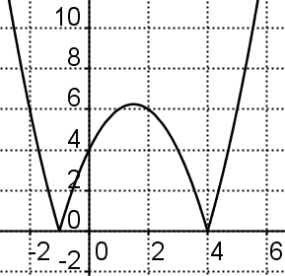

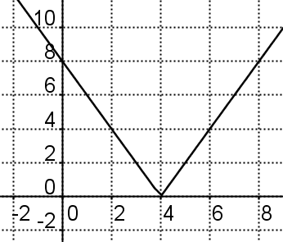

1. Solve: a. b.  c.  d. 
2. Graph a.  b. 
3. Solve graphically: a.  b. 
4. Solve algebraically: a.  b. 
5. Graph: a.  b.  c. 
6. Medium drinks cost $2 and large drinks cost $3. Let x be the number of medium drinks sold and y be the number of large drinks sold. Write the inequality to show how many drinks the vendor must sell to have at least $60 in sales?
7. Solve: a.  b.  c. 
8. Graph: a.  b.  c. 

***FINAL EXAM REVIEW ANSWERS***

|  |
| --- |
| 1a. 157 b. tn = 30n –53 2a. 17 b. 9 3. 67.2, 73.4, 79.6, 85.8 4a. tn = 4n +4 b. tn = -1.6n +11.4 5. $342 |
| 6a. 693 b. -651 7a. 388 b. -437 8. 13 9. Job A ($1275 to $1260) 10a. 16,384 b. |
| 11. ±1.4 12. 10,240 13a. 7.79km b. 45.7km 14a. 159.375 b. tn = 3.5(3n-1) 15a. 36.57 b. 280 |
| 16. 117 17a. 128.58cm b. 153.85 18a. 48˚ b. 62˚ c. 18˚ d. 23˚ |
| 19a. 1 b.  c. undefined d.  e. 1 f.  20a.  b.  c. -1 d.  e.  f. |
| 21.  22.  23a. 150˚, 330˚ b. 0˚, 180˚ c. 60˚, 300˚ |
| 24a. ∠D= 65.7˚ ∠C = 35.58˚ BD = 3.61 b. AB = 3.1 ∠A = 33.0˚ ∠B = 97.6˚  c. ∠C = 45.9˚ ∠B = 96.1˚ b = 58.1 **OR** ∠C = 134.1˚∠B = 7.9˚ b = 8.0 |
| 25a. The graph moves 5 to the left and 4 up. b. The graph is vertically compressed by half and moved down 9 |
| 26a. b. c. d. |
| 27. Vertex: (-5, -1) ; Axis of Symmetry: x = -5 ; x –int: none ; y-int: -7.25 ; Domain: ARN Range: y ≤ -1 ; max of -1 |
| 28. 29.  30. (4, 10) 31a.  b. |
| 32a. 23 and 23 b. 3 and -3 c. $10.50 d. 200 ft by 300 ft |
| 33. 34a.  b.  c.  d.  e.    35a. x = 3, 5 b. x = -8, 2 c. x =  d. 0, 2 e. x = ±2  36a.  b.  c.  37a. 4 by 7 b. -3 or 7 c. 4 or -5  38a.  b.  c. 1008 39a.  b.  c.  d. |
| 40a.  b.  41a.  b.  c.  42a.  b.  c.  d.  e. |
| 43a.  b.  c. 11 44a.  b.  c. |
| 45a. x = 10.5 b. no solution c. x = 36 d. no solution 46a.  b.  c. No NPV d. No NPV e. |
| 47a.  b.  c.  d. -2 e.  48 a.  b.  c.  d. -8  e. |
| 49a.  b.  c.  d.  e.  f.  g. |
| 50a. x = 12 b. x =  c. x = -1 d. No Solution e. x = -1 51a. 2, 7 b.  hrs c. 4 hrs d. 7 mph |
| 52a. b. 53a. x = 5, 9 b. x = -3,      c. x = -4.6, 6 d. x = -1, 12  Domain: ARN Range: y ≥ 0 Domain: ARN Range: y ≥ 0 |
| 54a. b.      55a. b. 56a. No Solution b. x = 1, 2      57a. b. c. |
| 58. 2x + 3y ≥ 60 59a. x < -3 or x > 2 b. -4 ≤ x ≤ 1 c. |
| 59a. b. c. |

